Effects of the Black Death —
source response
Student booklet
Name:
 | 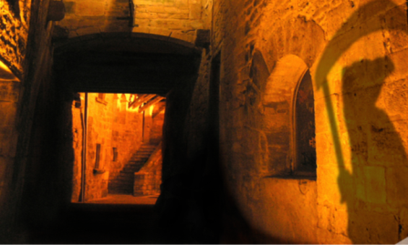 | Australian Curriculum History  Year 8
Investigate social changes in medieval Europe as a result of the Black Death.
You will:
- draw conclusions about how a source can be useful
- use evidence in explanations.
© The State of Queensland (Queensland Studies Authority) and its licensors 2012. All web links correct at time of publication.
Image: Sarlat - Passage - Shoes on Wires, Justus Hayes, Creative Commons Attribution 2.0, www.flickr.com/photos/shoes_on_wires/2339951157

Section 1. Using a source
Interpret and analyse the following sources to see how they can be useful in understanding the effects of the Black Death (also known as “the plague”). You will use the information from your analysis to answer the key inquiry question at the end of the assessment: How did immediate and long-term effects of the Black Death change medieval society in Europe?
Source A
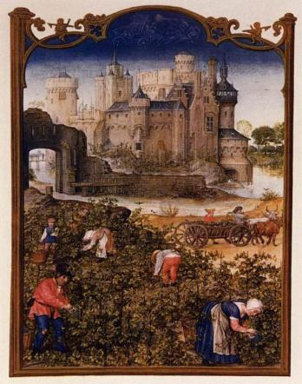 | Source A is an illustration from the Grimani Breviary.  This was a document created in the 14th century and gave information about the types of plants and farming to be done during the year.  This illustration is for the month of September.

- Identify three aspects of medieval life that are seen in Source A.

Source B
Source B is a secondary source that shows world population growth throughout history. Historians have different opinions on exactly how many people died as a result of the Black Death.
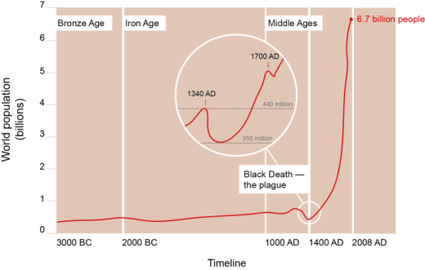

- a. Use information from Source B to describe the impact of the Black Death on world population after 1348.

b. Why might historians disagree about the number of people who died because of the Black Death in the medieval period? Explain your reasoning.

c. There is more information about the effects of the Black Death on European populations than anywhere else. Why might there be less information about the effect on Asian and African populations? Explain your reasoning.

Source C
In Source C Matteo Villani, who lived in Florence (Italy) during the time of the plague, describes what life was like during and after the Black Death. After reading the source, respond to the following question.
“Men dreamed of wealth and abundance in garments and in all other things … beyond meat and drink; yet, in fact, things turned out widely different; for most [luxury] commodities were more costly, by twice or more, than before the plague. And the price of labour, and the work of all trades and crafts, rose in disorderly fashion beyond the double.”

- Why might this source be useful? Describe the useful information it contains for historians.

Source D
Source D is from a law that King Edward III made in 1351, just two years after the Black Death first hit England. The law, called the Statute of Laborers, stated that peasants could not receive wages that were more than they had been paid before the “pestilence” (plague). The nobles had complained to him that peasants were demanding to be paid more and were leaving their villages to travel to new jobs where they were getting higher wages.
“Because a great part of the people and especially of the workmen and servants has now died in that pestilence, some, seeing the straights of the masters and the scarcity of servants, are not willing to serve unless they receive excessive wages … Every man and woman of our kingdom of England, of whatever condition … shall take only the wages liveries, meed or salary which, in the places where he sought to serve, were accustomed to be paid in the twentieth year of our reign of England.”

- Based on this source, what might an adult male say to his family about the law and his opinion of it?

Source E
Source E was written by Henry Knighton, a man who lived through the Black Death and described its immediate effects in his book History of England from the 14th century.
“Sheep and cattle went wandering … and there was no one to go and drive or gather them … many crops perished in the fields for want of someone to gather them.
But the peasants were so lifted up and obstinate that they would not listen to the king's command, but if anyone wished to have them he had to give them what they wanted, and either lose his fruit and crops, or satisfy the wishes of the workmen.
After the pestilence, many buildings, great and small, fell into ruins in every city for lack of inhabitants, likewise many villages and hamlets became desolate … it was probable that many such villages would never be inhabited.”

- List the immediate effects of the Black Death described in Henry Knighton’s writing.

- Circle the immediate effect in your list that would have had the greatest impact on society at the time. Explain why it had the greatest impact with reference to the source.

- Knighton described the buildings that “fell into ruins” and the “desolate” villages.
What does this information tell you about the impact of the Black Death on populations in Europe?

Source F
Source F is drawn from 14th-century records of Savarnak House in England, showing the wage per day for a peasant who worked on farms or in workshops.
One of the long-term effects of the Black Death was a change in the amount of power peasants had. Because the huge death toll meant a smaller workforce, the remaining peasants were suddenly more important. Nobles were forced to pay them more to ensure the work was done on the farms. Source F shows how much wages in England had grown just 11 years after the Black Death first occurred.
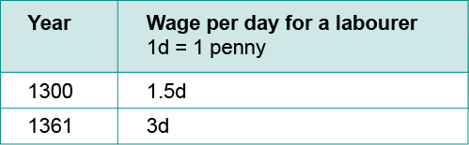

- Consider how the information in Source F is both useful and limited in helping historians to understand how peasants became more powerful in society after the Black Death.
Explain your reasoning with reference to the source.

- Which source has been the most useful in giving you an understanding about how the Black Death affected Europe? Explain your reasoning with reference to the source.

Identifying cause and effect
The following sources require you to focus on the concept of cause and effect in relation to the Black Death and society in medieval Europe. You will use the information from your analysis to answer the key inquiry question at the end of the assessment: How did immediate and long-term effects of the Black Death change medieval society in Europe?
Source G
Source G is a passage from a speech by John Ball in 1381. Ball was a priest who protested against the way the peasants were treated by the nobles. He travelled throughout England speaking to peasants about the injustices in society.
“Good people, things cannot go right in England and never will, until goods are held in common, and there are no more villeins and gentlefolk, but we are all one and united. In what way are those we call lords, greater masters than ourselves? If we all spring from a single father and mother, Adam and Eve, how can they claim or prove they are more lords than us?”

- Complete boxes 8, 9 and 10 in the graphic organiser to predict what may have happened in England as a result of John Ball’s speeches. The first examples demonstrate how cause and effect can unfold.
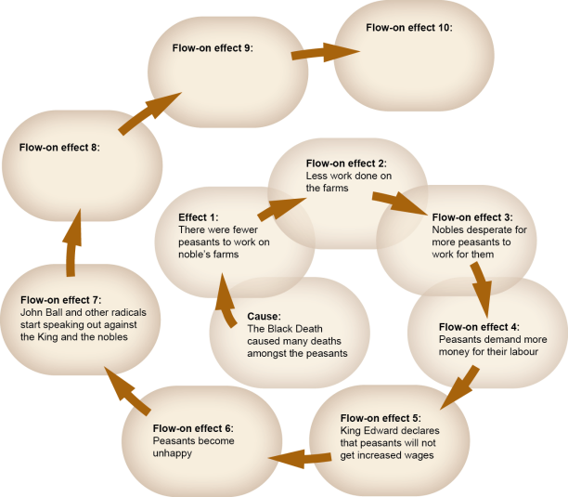
Source H
In Source H Froissart describes what happened when the Jacquerie led a rebellion in 1358. (Jacquerie was the name given to the rebellious peasants).
“Men-at-arms of every kind burst out of the gates and ran into the square to attack those evil men [the peasants]. They mowed them down in heaps and slaughtered them like cattle; and they drove all the rest out of the town, for none of the villeins attempted to take up any sort of fighting order … Never did men commit such vile deeds (as those Jacquerie); I could never bring myself to write down what they did to women … God by His grace provided a remedy … The nobles wiped them out wherever they found them, without mercy or pity.”

Sources H and I
All over Europe peasants were becoming increasingly unhappy with the lives that nobles were forcing them to live. In many places, the peasants grew so unhappy that they rebelled against the nobles. Jean Froissart, who lived in France during the 1300s, wrote a chronicle in which he recorded many events.

Source I
The image in Source I Defeat at Meaux is an illustration from Froissart’s chronicle of what happened when peasants rebelled in a French town called Meaux. | 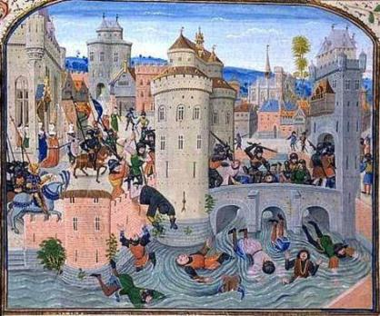

- Sources H and I focus on one of the effects of the Black Death: social uprising and rebellion.
Complete the graphic organiser below to show the cause and effect of peasant uprisings such as those recorded in Sources H and I.
Cause | Event | Effect

Peasants
formed groups (known as Jacquerie) to protest and rebel against the conditions forced on them by the noble class.

- The Black Death caused many changes in medieval European society. Would the feudal pyramid still be an accurate way to show how society was structured after the peasant revolts and wage increases in Europe?
Explain your answer below with reference to the sources throughout Sections 1 and 2.

- Explaining the effects of the Black Death
- Create a list of historical terms that you could use in your explanation.
Some of the terms refer to the medieval period and some will refer to the study of history. We have included some examples to get you started.
Specific to this time period in history | Used in the study of history
peasants  nobles | social structures  power

- How did immediate and long-term effects of the Black Death change medieval society in Europe?
Use historical terms from Q12 and evidence from a range of sources in your answer.

